CCNP Period 6-7

1/14/18

VRF lite– Virtual routing and forwarding

Jeffrey Xu

Purpose:

This lab introduced us to a protocol that is similar to VLANs on switches, where you are able to make many VLANS to virtualize a network. On a router, it is called VRF: Virtual Routing and Forwarding. It allows us to split the router into virtual routers that never interact with each other. It is like having an almost infinite amount of routers in one router only limited to the resources such as memory and processor. A reason we would implement this protocol would be to keep sensitive data or traffic in a separate channel such as business transactions. While you can have public traffic running on a public VRF instance. It is like traffic where carpool is able to have their own lane and everyone else has to drive on the other lanes.

Background:

A lab like this was only slightly harder than multi-area OSPF and significantly easier than Tacacs+ and Radius. VRF acts as a logical (virtual) router where you may have more than one instance of a router limited by resources. VRF allows us to save on hardware when you want to make a dedicated link to another router but instead, you can create your own VRF and have your traffic run through a virtual router that no other network of traffic can use. But VRF by itself doesn’t allow it to have ip connectivity. For that, we implemented OPSF VRF, it allows that specific VRF to communicate with other routers and switches that are on the same OSPF VRF network. We can verify this by pinging across routers with that command do ping 192.168.1.1 vrf [vrf name] or other commands similar to this one while adding the –vrf [vrf name] at the end of it such as ip route and ip connectivity commands. We also needed to allow ip routing on the switches and create VLANS for the sub-interfaces which the VRF routers would be running from. Which was basically implementing Router on a stick (Roast). The two VRFS would be bound to different vlans and would never talk. Even the routing tables on the routers wouldn’t show the routes unless you specifically called for that VRF’s routing table.

Lab Setup:

For this lab, we used 2 3750 layer 3 switches, 3 2901 routers, and 2 PC. We implemented VRF for the virtualization and OSPF VRF for the ip connectivity. Although you can use loopback interfaces to verify ip connectivity across networks.

**Topology:**

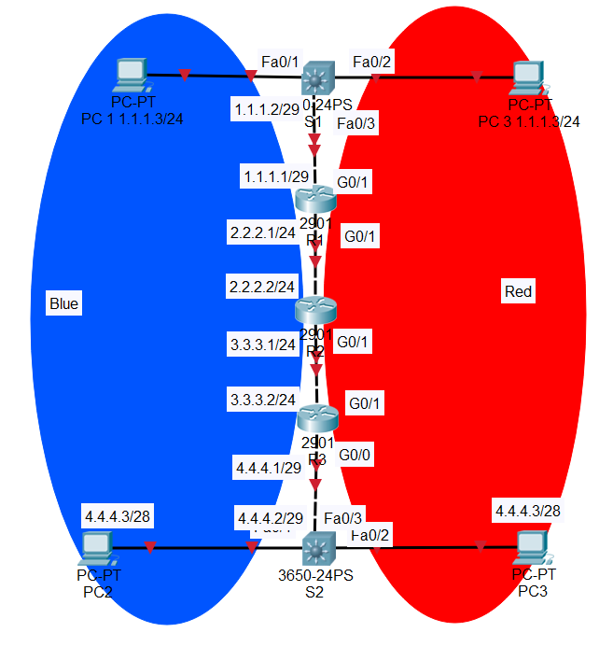

**Switch 1 Configurations:**

hostname S1

ip routing

ip vrf blue

ip vrf red

vlan internal allocation policy ascending

interface FastEthernet1/0/1

switchport trunk encapsulation dot1q

switchport trunk allowed vlan 2,3

switchport mode trunk

interface FastEthernet1/0/2

switchport access vlan 2

interface FastEthernet1/0/3

switchport access vlan 3

interface Vlan1

no ip address

interface Vlan2

ip vrf forwarding red

ip address 1.1.1.1 255.255.255.248

interface Vlan3

ip vrf forwarding blue

ip address 1.1.1.1 255.255.255.248

router ospf 1 vrf red

router-id 1.1.1.1

network 1.1.1.0 0.0.0.7 area 0

network 1.1.1.0 0.0.0.255 area 0

router ospf 2 vrf blue

network 1.1.1.0 0.0.0.7 area 0

network 1.1.1.0 0.0.0.255 area 0

**Switch 2 Configurations:**

hostname S2

ip routing

ip vrf blue

ip vrf red

vlan internal allocation policy ascending

interface FastEthernet1/0/1

switchport trunk encapsulation dot1q

switchport trunk allowed vlan 2,3

switchport mode trunk

interface FastEthernet1/0/2

switchport access vlan 2

interface FastEthernet1/0/3

switchport access vlan 3

interface Vlan2

ip vrf forwarding red

ip address 4.4.4.2 255.255.255.248

interface Vlan3

ip vrf forwarding blue

ip address 4.4.4.2 255.255.255.248

router ospf 1 vrf red

router-id 9.9.9.9

network 4.4.4.0 0.0.0.7 area 0

router ospf 2 vrf blue

router-id 10.10.10.10

network 4.4.4.0 0.0.0.7 area 0

**Router 1 Configurations:**

hostname R1

ip vrf blue

ip vrf red

interface GigabitEthernet0/0

ip address 2.2.2.1 255.255.255.252

duplex auto

speed auto

interface GigabitEthernet0/0.2

encapsulation dot1Q 2

ip vrf forwarding red

ip address 2.2.2.1 255.255.255.252

interface GigabitEthernet0/0.3

encapsulation dot1Q 3

ip vrf forwarding blue

ip address 2.2.2.1 255.255.255.252

interface GigabitEthernet0/1

ip address 1.1.1.2 255.255.255.252

interface GigabitEthernet0/1.2

encapsulation dot1Q 2

ip vrf forwarding red

ip address 1.1.1.2 255.255.255.248

interface GigabitEthernet0/1.3

encapsulation dot1Q 3

ip vrf forwarding blue

ip address 1.1.1.2 255.255.255.248

router ospf 1 vrf red

router-id 3.3.3.3

redistribute static

network 1.1.1.0 0.0.0.7 area 0

network 2.2.2.0 0.0.0.3 area 0

router ospf 2 vrf blue

router-id 4.4.4.4

network 1.1.1.0 0.0.0.7 area 0

network 2.2.2.0 0.0.0.3 area 0

**Router 2 Configurations:**

hostname R2

ip vrf blue

ip vrf red

interface GigabitEthernet0/0

ip address 3.3.3.1 255.255.255.252

duplex auto

speed auto

interface GigabitEthernet0/0.2

encapsulation dot1Q 2

ip vrf forwarding red

ip address 3.3.3.1 255.255.255.252

interface GigabitEthernet0/0.3

encapsulation dot1Q 3

ip vrf forwarding blue

ip address 3.3.3.1 255.255.255.252

interface GigabitEthernet0/1

ip address 2.2.2.2 255.255.255.252

duplex auto

speed auto

interface GigabitEthernet0/1.2

encapsulation dot1Q 2

ip vrf forwarding red

ip address 2.2.2.2 255.255.255.252

interface GigabitEthernet0/1.3

encapsulation dot1Q 3

ip vrf forwarding blue

ip address 2.2.2.2 255.255.255.252

router ospf 1 vrf red

router-id 5.5.5.5

network 2.2.2.0 0.0.0.3 area 0

network 3.3.3.0 0.0.0.3 area 0

router ospf 2 vrf blue

router-id 6.6.6.6

network 2.2.2.0 0.0.0.3 area 0

network 3.3.3.0 0.0.0.3 area 0

**Router 3 Configurations:**

hostname R3

ip vrf blue

ip vrf red

interface GigabitEthernet0/0

no ip address

duplex auto

speed auto

interface GigabitEthernet0/0.2

encapsulation dot1Q 2

ip vrf forwarding red

ip address 4.4.4.1 255.255.255.248

interface GigabitEthernet0/0.3

encapsulation dot1Q 3

ip vrf forwarding blue

ip address 4.4.4.1 255.255.255.248

interface GigabitEthernet0/1

no ip address

duplex auto

speed auto

interface GigabitEthernet0/1.2

encapsulation dot1Q 2

ip vrf forwarding red

ip address 3.3.3.2 255.255.255.252

interface GigabitEthernet0/1.3

encapsulation dot1Q 3

ip vrf forwarding blue

ip address 3.3.3.2 255.255.255.252

router ospf 1 vrf red

router-id 7.7.7.7

network 3.3.3.0 0.0.0.3 area 0

network 4.4.4.0 0.0.0.7 area 0

router ospf 2 vrf blue

router-id 8.8.8.8

network 3.3.3.0 0.0.0.3 area 0

network 4.4.4.0 0.0.0.7 area 0

**Screen shots:**

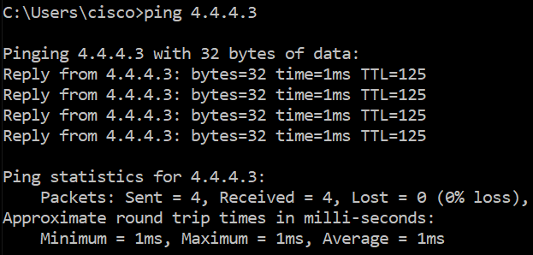

This ping was from 2 pc on the same VRFs

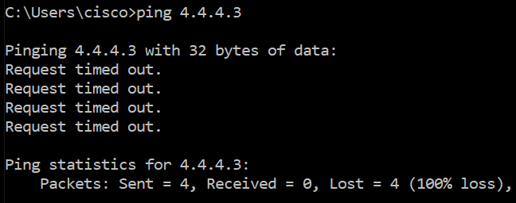

This was from 2 pc on different VRFs

**Problems:**

This was a fairly fast lab, some problems I ran into were that the two types of layer 3 switches we have don’t support sub-interfaces on their fast Ethernet ports nor on the gigabit Ethernet ports which forced me to use trunking and vlans to make up for it. Another problem was finding the correct commands for VRF OSPF and switch setup guides. Because most of the guides online were for routers not switches.

**Conclusion:**

I feel like this was a pretty relaxed lab where I was able to learn something fast. Lots of trial and error when I was messing around with the OSPF commands and the guides online were pretty vague on which commands I could use and which ones were optional. And it also had a bunch on VPN stuff which messed around with my research. I have a feeling the normal VRF is going to be much more confusing the VRF lite.